**Configuring, Provisioning, and Monitoring Node.js Application = Capstone Project no 2**

**Process:**

**Set Up AWS Resources**

Logged in to AWS Management Console.  
• Launched EC2 Instance: (virtual machine - Ubuntu).

And security groups to allowed SSH (port 22) traffic with instance type - T2.medium and 15Gb disk size and created PPK file.

**Connect to Your EC2 Instance**

•    Used SSH to connect to EC2 instance using the PPK file via Putty as below.

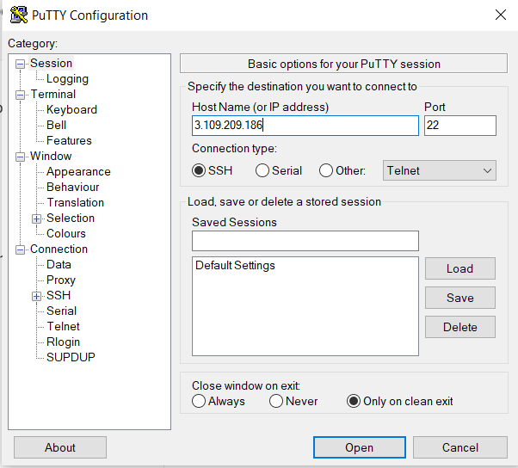

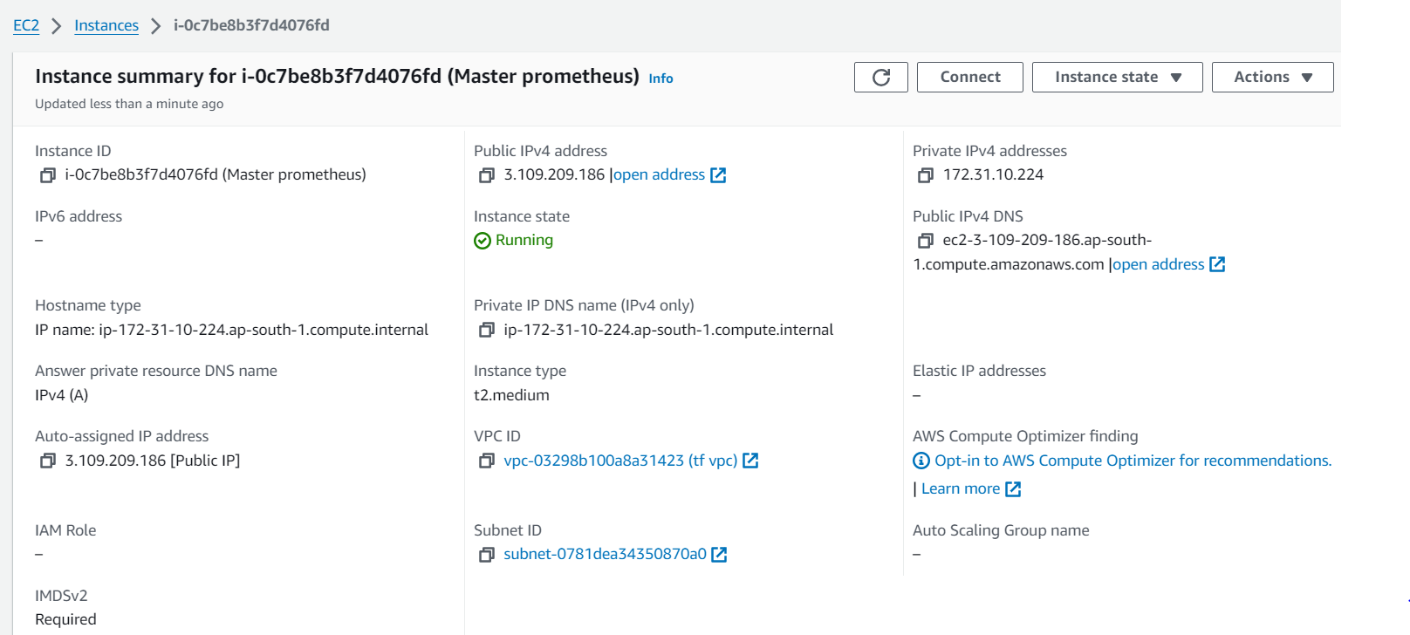

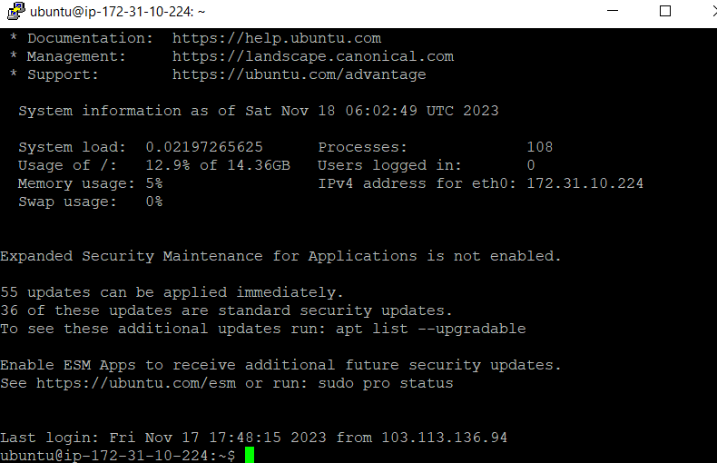

**Installed docker on to the machine as below:**

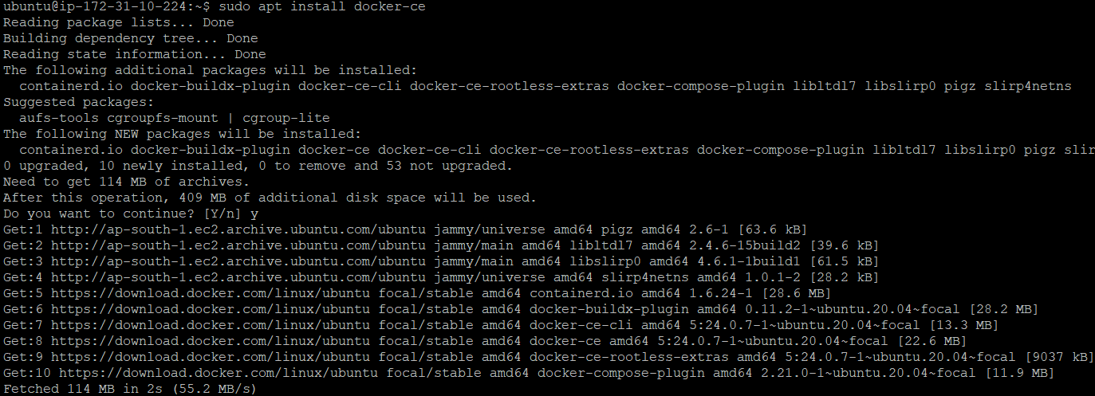

**Cloned the Git repo and code on to the machine as below:**

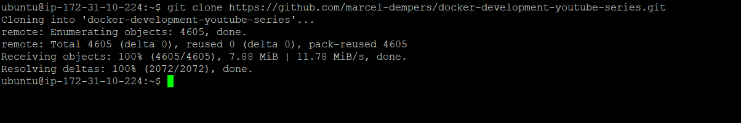

**Change directory to the source code repo for building the docker file :**

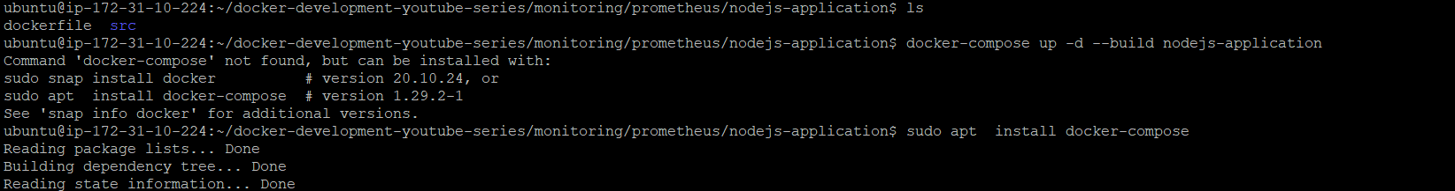

**Here I used docker compose concept as we are deploying multiple docker containers(microservice) so installed docker-compose as below:**

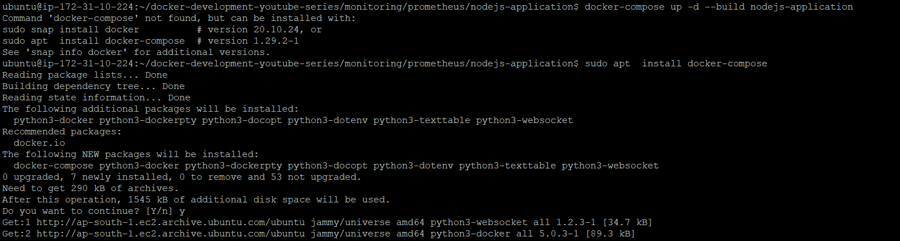



**Below is the command for building the nodejs-application that is building**

**Docker file.**

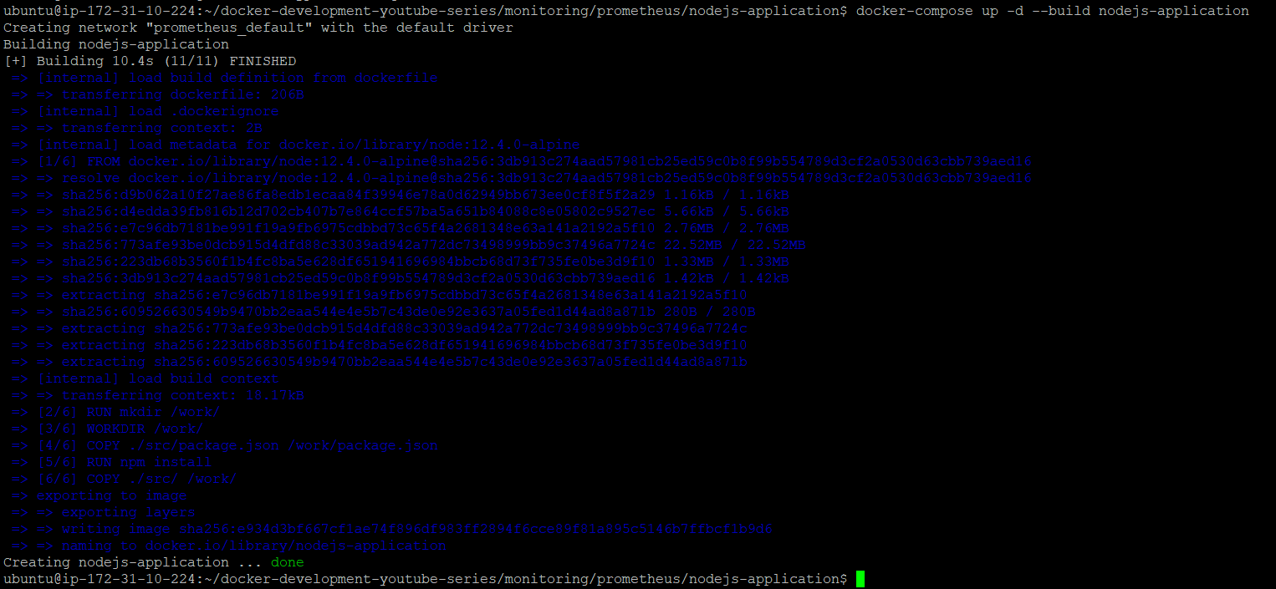

**Docker File :**

FROM node:12.4.0-alpine as dev

RUN mkdir /work/

WORKDIR /work/

COPY ./src/package.json /work/package.json

RUN npm install

COPY ./src/ /work/

CMD node .

**Now checked running images in the machine using below command**

* docker images



**As app is running on port 83 so added port entry to the SG as below:**

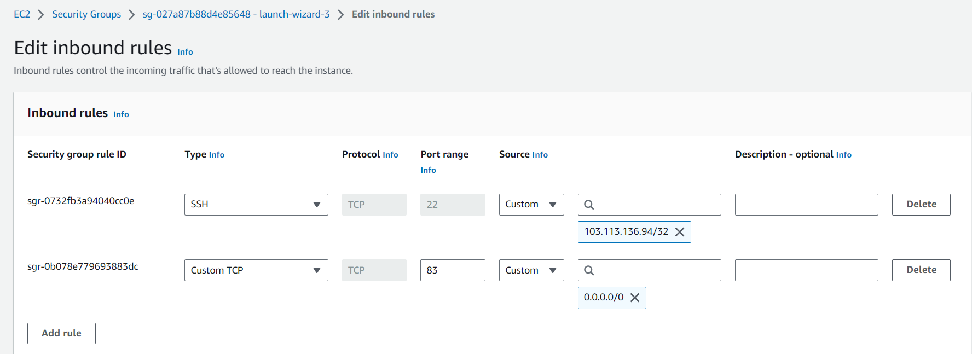

**And visit to website by hit IP and port no as below :**

Running App:

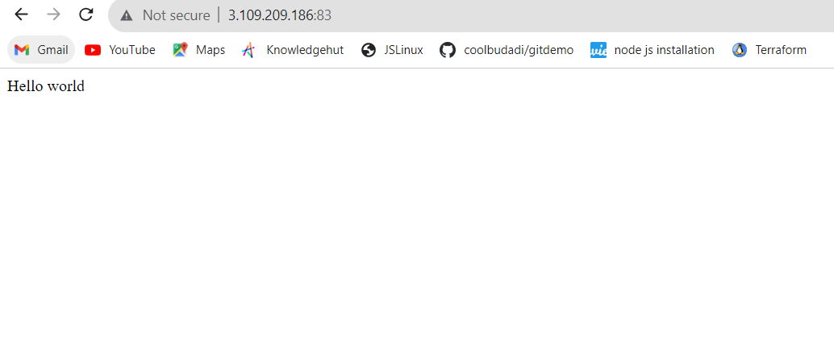

**Downloaded and created Prometheus ,Grafana , Grafana Dashboard services by using docker compose as below:**

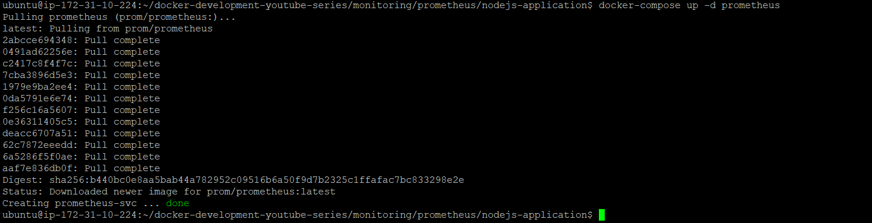

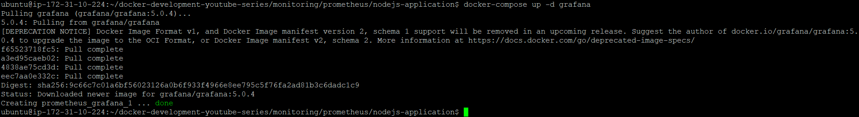

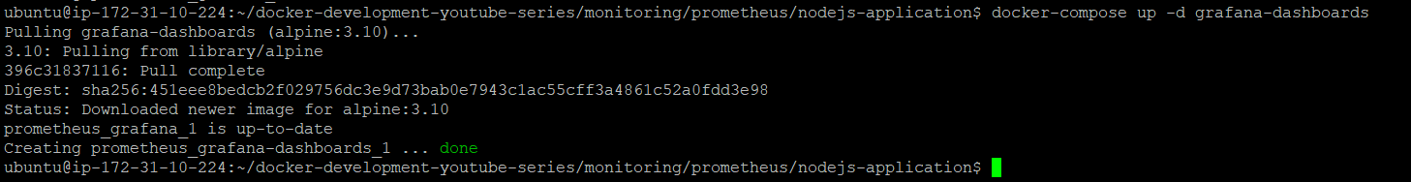

**As Prometheus running on Port 9091 so added as entry to SG as below:**

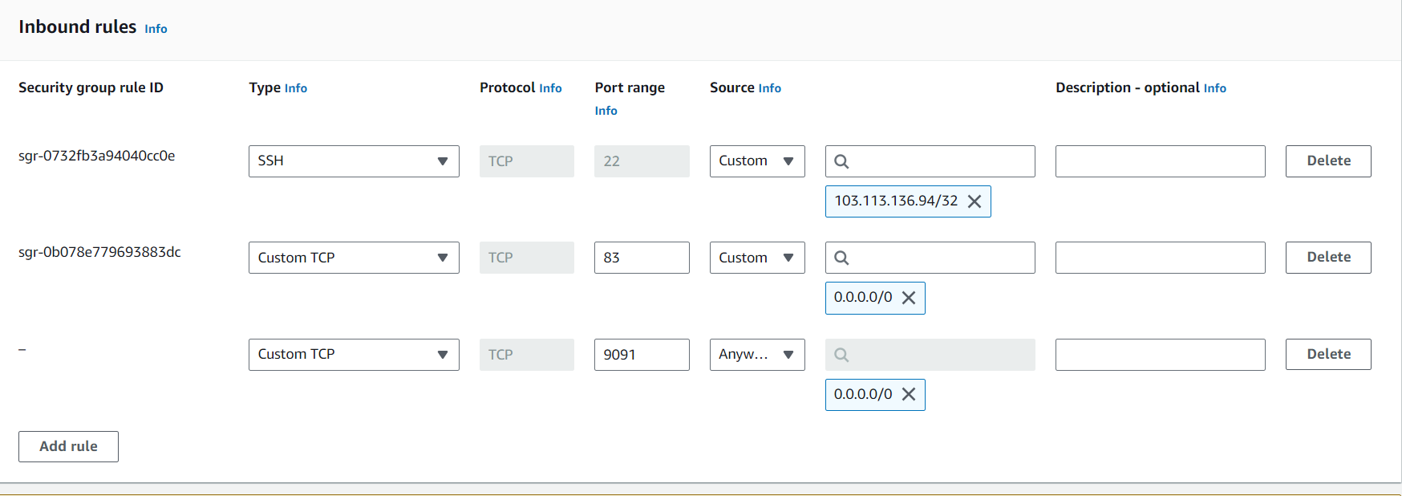

**And got Prometheus server as below:**

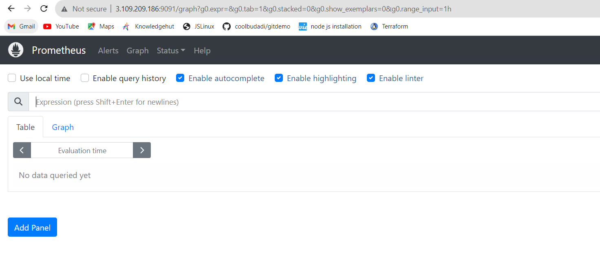

**As we can see Targets are showing in UP state.**

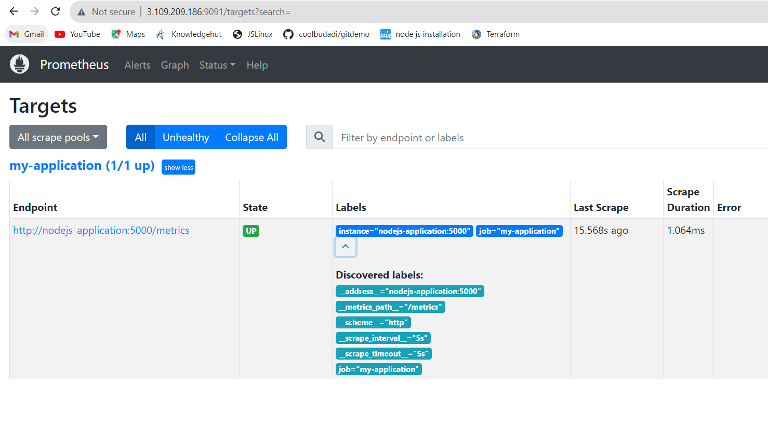

**As Grafana running on Port 3000 so added as entry to SG as below:**

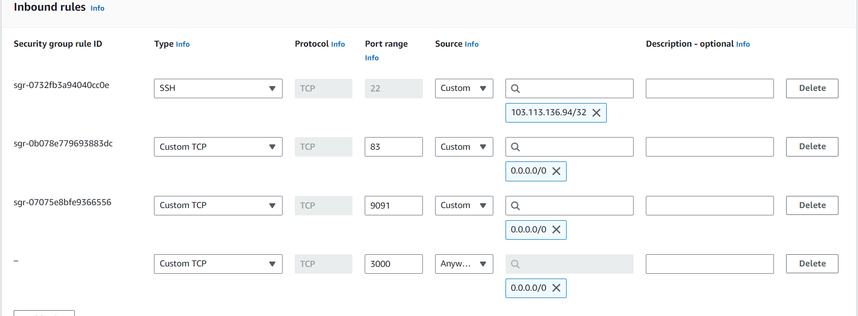

**And we got below result as below:**

**We created Grafana dashboard for monitoring node js application as below:**

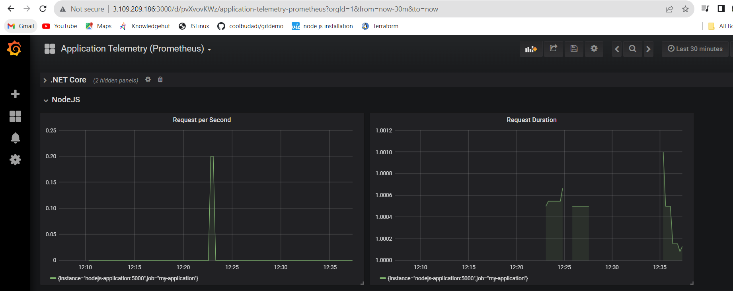

Git Repo for application source:

<https://github.com/marcel-dempers/docker-development-youtube-series/tree/master/monitoring/prometheus/nodejs-application>

Prometheus File:

global:

scrape_interval: 5s

evaluation_interval: 30s

scrape_configs:

- job_name: my-application

honor_labels: true

static_configs:

- targets: ['go-application:5000','python-application:5000','dotnet-application:5000','nodejs-application:5000']

Docker Compose File:

version: "3"

services:

nodejs-application:

build:

context: ./nodejs-application

container_name: nodejs-application

image: nodejs-application

ports:

- "83:5000"

prometheus:

container_name: prometheus-svc

image: prom/prometheus

ports:

- "9091:9090"

command: --config.file=/etc/prometheus/prometheus.yaml

volumes:

- ./prometheus.yaml:/etc/prometheus/prometheus.yaml

grafana:

image: grafana/grafana:5.0.4

ports:

- "3000:3000"

environment:

- GF_AUTH_BASIC_ENABLED=false

- GF_AUTH_ANONYMOUS_ENABLED=true

- GF_AUTH_ANONYMOUS_ORG_ROLE=Admin

grafana-dashboards:

image: alpine:3.10

depends_on:

- grafana

volumes:

- ./grafana-data:/grafana

command: >

/bin/sh -c "

apk add --no-cache curl

echo 'waiting for grafana'

sleep 5s

cd /grafana

curl --request POST http://grafana:3000/api/datasources --header 'Content-Type: application/json' -d @datasources.json

curl --request POST http://grafana:3000/api/dashboards/db --header 'Content-Type: application/json' -d @dashboard.json"